Subtraction of Integers with the help of a Number Line
When we subtract a positive integer, we move to the left.
When we subtract a negative integer, we move to the right because we get a greater integer. For e.g. 4- (-2) = 4+2 = 6.
The subtraction of an integer is the same as the addition of its additive inverse. To subtract an integer from another integer it is enough to add the additive inverse of the integer that is being subtracted, to the other integer.
For e.g. In the case of 4 - (-2), the additive inverse of -2 can be used. The additive inverse of -2 is 2.
So we can add 2 to 4 and get; 2+4 =6

Problem: Find (– 12) – (– 8).

Subtracting -8 from -12 is same as adding the additive inverse of -8 to 12.
Additive inverse of -8 is 8
Therefore, -12 - (-8) = -12 + 8

Step 1. Locate -12 on number line
Step 2. We have to add a positive integer 8 . So we take 8 jumps towards right
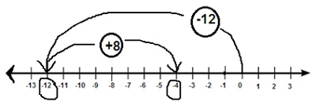
Step 3. We reach -4

